ASSINGMENT – 30

Create package using package body with procedure of table to update salary

Package Creation:

CREATE OR REPLACE PACKAGE employee_pkg AS

PROCEDURE update_salary(

p_emp_id IN employees.EMP_ID%TYPE,

p_emp_salary IN employees.salary%TYPE);

END employee_pkg;

/

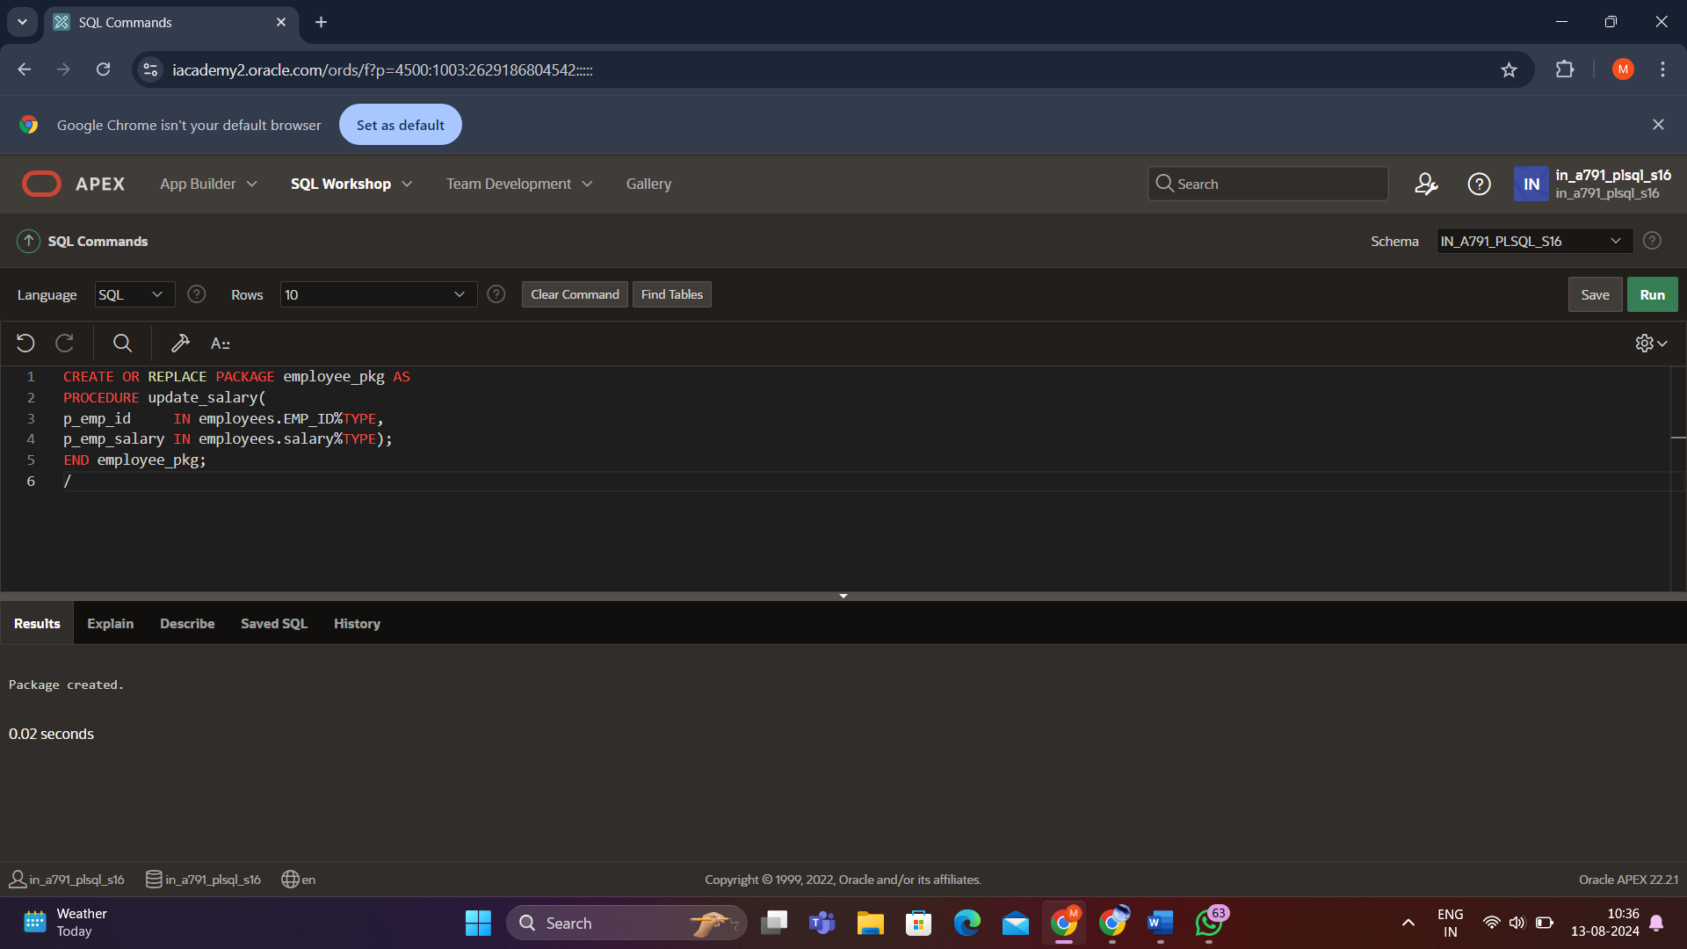

Package body creation:

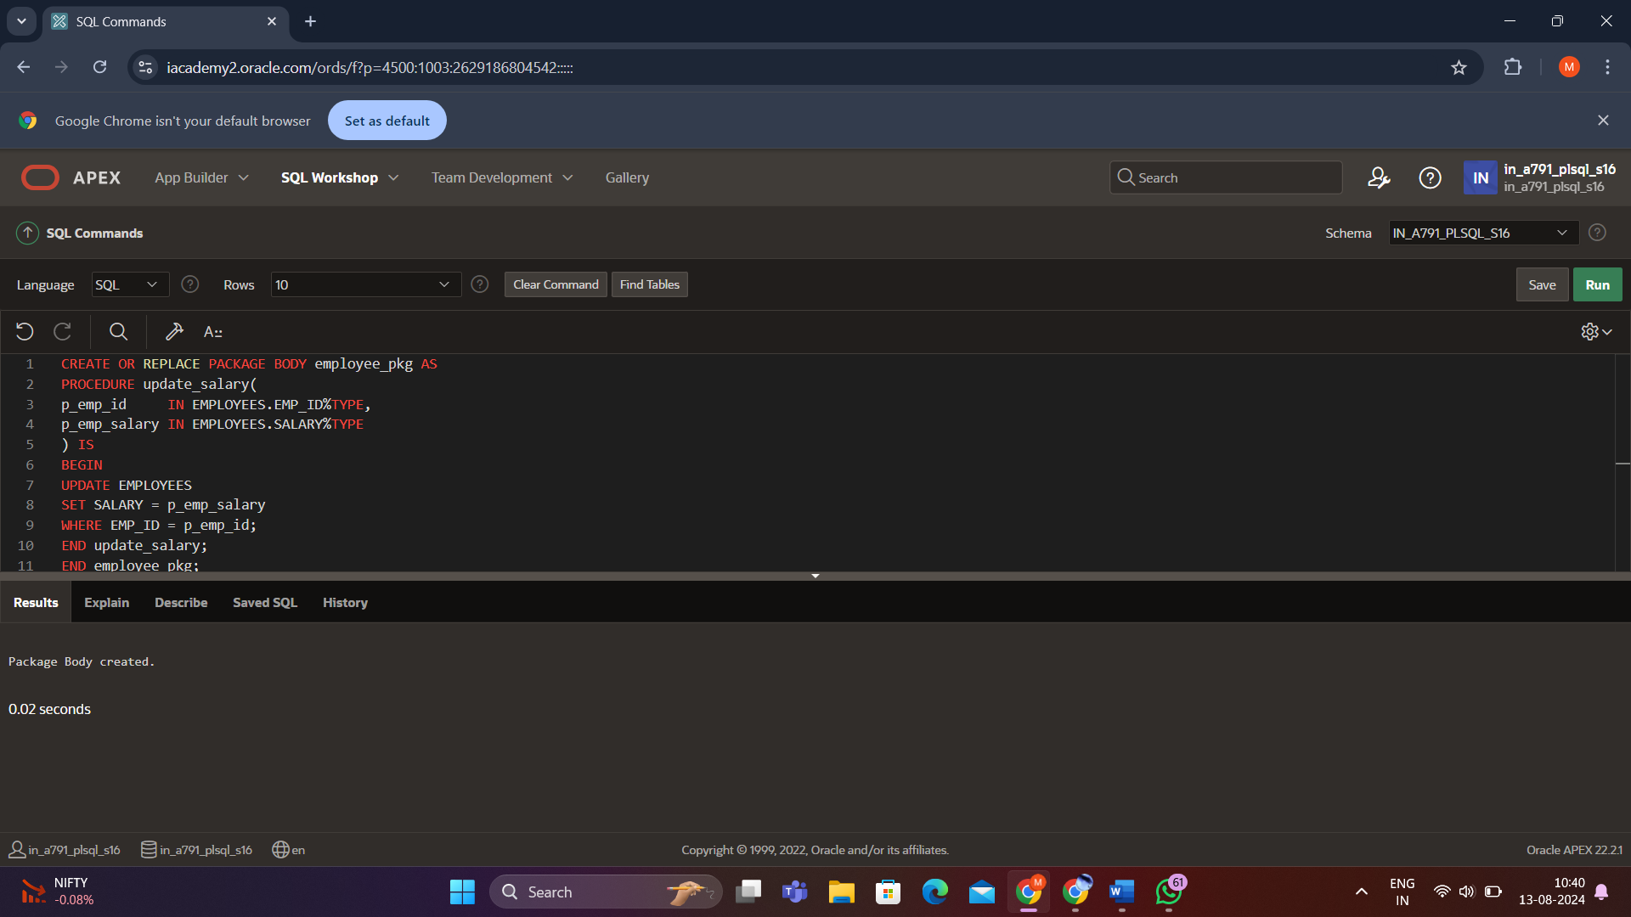

Output:

BEGIN

EMPLOYEE_PKG.UPDATE_SALARY(6,200000);

END;

/

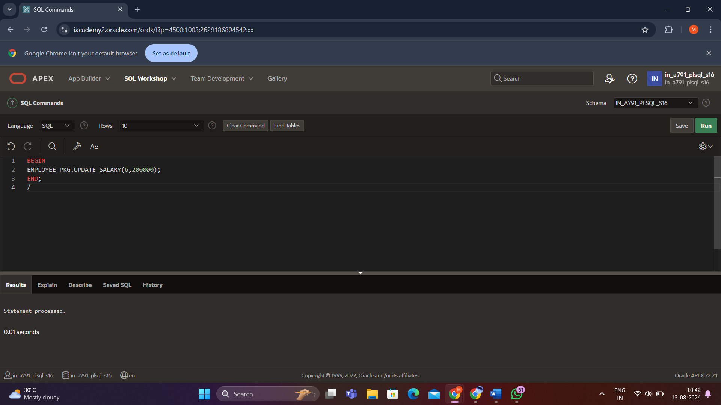

Select * from employees

